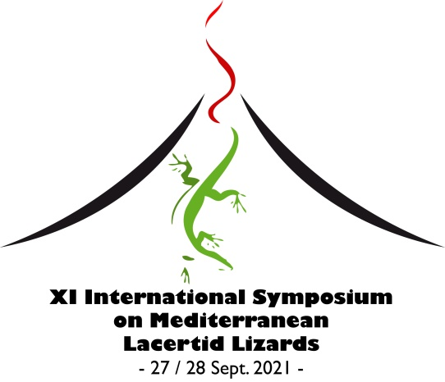

11th Symposium on the Lacertids of the Mediterranean Basin
online from Lipari (Aeolian Archipelago, Italy), 27-28.09.2021

First circular

The 11th Symposium on the Lacertids of the Mediterranean Basin will be held online on 27-28th September 2021.
The Organising Committee apologises for this delayed announcement of the Symposium, which is mainly due to the uncertainties related to the current sanitary situation. The colleagues from Croatia, who originally proposed to organise the Symposium were prevented from doing so by the earthquakes that struck their country. Consequently, we have undertaken to organise it in Italy. The Symposium should have been held in Lipari, Aeolian Islands (Italy), soon after the XIII National Congress of the Societas Herpetologica Italica (http://www-9.unipv.it/webshi/news/13congress.htm). However, even if confident in a positive development of the sanitary situation, but conscious of the possible limitations to international mobility, the Organising Committee has decided to hold the Symposium fully online.

ORGANISING COMMITTEE
Pietro Lo Cascio, Claudia Corti, Marta Biaggini, Miguel Angel Carretero, Petros Lymberakis.

SCIENTIFIC COMMITTEE
Zuhair Amr, Marine Arakelyan, Marta Biaggini, Wolfgang Böhme, Amos Bouskila, Miguel Angel Carretero, Claudia Corti, Pierre-André Crochet, Soumia Fahd, Paolo Faraone, Johannes Foufopoulos, Irena Grbac, David James Harris, Klaus Henle, Anthony Herrel, Souad Hraoui-Bloquet, Antigoni Kaliontzopoulou, Pietro Lo Cascio, Petros Lymberakis, Shai Meiri, Panayiotis Pafilis, Valentín Pérez-Mellado, Martina Podnar, Nikos Poulakakis, Catarina Rato, Vicente Roca, Roberto Sacchi, Neftali Sillero, Efstratios Valakos, Raul Van Damme, Anamarija Žagar, Savvas Zotos.

PRELIMINARY SCIENTIFIC PROGRAMME
The symposium will focus on different aspects of research carried out on Mediterranean Lacertid lizards. Eminent contributions on lizard biology from other zoogeographical regions will also be considered. The symposium will include plenary lectures and regular sessions that will consist of oral communications and brief oral communications replacing posters (see below). Suggestions for session and workshop topics are welcome.
Each session will be moderated by one/two chairpersons.

SCIENTIFIC CONTRIBUTIONS
Scientific contributions will be presented as oral communications or brief oral communications replacing posters.
Oral communications (PPT) will last about 15 minutes, including discussion.
Brief oral communications (PPT) lasting 5 minutes, will be used to present contents that are usually summarized in posters in onsite meetings.

For each scientific contribution, participants are supposed to send the abstract and a manuscript (optional) within the deadlines below. Authors should indicate their preferred form of presentation (oral communication or brief oral communication); the final decision will be evaluated by the Organising Committee and the Scientific Committee and communicated within 15th July 2021.

Only scientific contributions sent together with the registration form and the receipt of the registration fee payment will be considered for the review process. Permits - if required in the Country where research was performed - must be clearly addressed in the manuscripts.

ABSTRACT BOOK: An Abstract book, including the abstracts of all the accepted contributions, will be emailed to participants, along with the scientific programme.

MANUSCRIPT PUBLICATION: Manuscripts sent as part of scientific contributions of the 11th Symposium on the Lacertids of the Mediterranean Basin will be submitted for publication in a Special Issue (or Special Section, depending on the number of submissions) of Acta Herpetologica (IF₂₀₁₉ 0.633). Manuscripts will undergo the usual reviewing process and rules for acceptance of the journal. Further information will be given in the Second Circular.

REGISTRATION FEES AND PAYMENT INFO
Participants are kindly asked to send the registration form within 20th May 2021, to be completed with the registration fee payment as indicated below.

Early bird registration, until 20th May 2021: 50€
Late registration, after 20th May 2021: 60€

Please, pay the fee by bank transfer to the following account:
IBAN IT75 Y 05034 26000 000000000403
SWIFT BAPPIT21P60
In favour of: Associazione Nesos
Specifying the reason for payment: Surname, Name, 11th Lacertid Symposium.

There is no refund of the registration fee in case of non-participation

OFFICIAL LANGUAGE
The official language of the Symposium is English.

DEADLINES:
• 20th May 2021: early bird registration.
• 10th June 2021: abstract submission.
•15th July 2021: notification of abstract acceptance/rejection; notification of the selected presentation format (oral communication or brief oral communication).
• 15th October 2021 manuscript submission

The second circular will be sent within end May 2021.
For further information and updates, visit the website http://www.nesos.org/XISymposiumMedLizard/index.html

CONTACTS
E-mail to: claudia.corti@unifi.it and plocascio@nesos.org

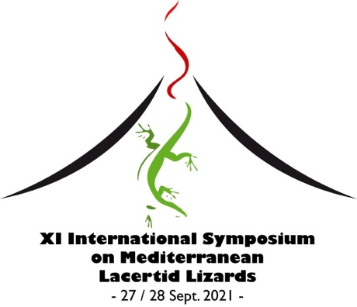

online from Lipari, Aeolian Islands, Italy

Registration Form

(*required field)

Name* ………………………………………………………………………………………….

Institution ………………………………………………………………………………………….

Address* ………………………………………………………………………………………….

Postal code* ………………………………………………………………………………….

Country* ………………………………………………………………………………………….

E-Mail* ……………………………………………………………………………………….....

Phone ..…………..………………………………………………………………………….....

I will present a scientific contribution* □ YES □ NO

in the following form* □ oral communication (15’)
□ brief oral communication (5’)

Preliminary title*:………………………………………………………………………………….....

…………….....…………..………………………………………………………………………….....

I will submit a manuscript* □ YES □ NO

Data regarding registration fee payment (bank, date, etc.) (please no later than 20.05.2021):

…………………………………………………………………………………………………………
…………………………………………………………………………………………………………

Please return this to: claudia.corti@unifi.it and plocascio.nesos@gmail.com

