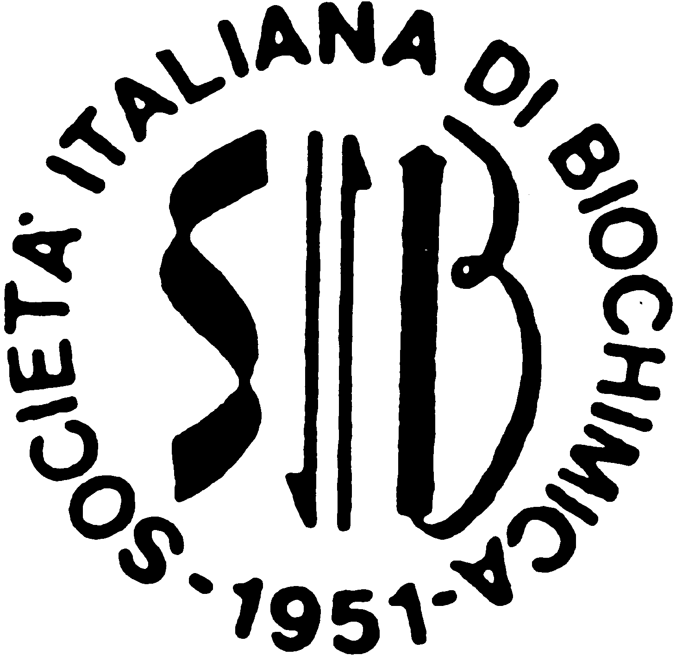**35a Riunione Nazionale *“A.* *Castellani”* dei  
Dottorandi di Ricerca in Discipline Biochimiche**

(35th *“A. Castellani”* Meeting of PhD students in Biochemical sciences)

# Brallo di Pregola (PV) 3 – 7 June 2025

**Rules for Abstract and Oral Presentation**

Here are a few notes on how to prepare the abstract for the oral presentation to be included in the abstract book.

* The official language of the meeting is ENGLISH.
* The oral presentation, supported by an appropriate number of slides, must not exceed 15 minutes, plus 5 minutes for discussion, all in English language.
* **Deadline for sending the abstract May 19th, 2023**
* The abstracts must be written using a word processor (no PDF!), with a Times New Roman 10 font, single line spacing, A4 page size with 2 cm margins on all sides, and the following structure:
* **Title in upper-case letters.**
* One empty line.
* **On a maximum of two lines:** Authors **(First, Last names in full)**, affiliation of the first (main) author (University, Department) and his/her email address.
* One empty line.
* **Text of the abstract, with a maximum 450 words, references excluded (max 3).**
* **A maximum of one simple figure, black and white or color.**

The text of the abstract must be sent electronically via email as an attachment to:

[riundott@unipv.it](mailto:riundott@unipv.it)

Do not embed the text of the abstract within the body of the email message.

Remember to rename the attached file with YOUR FIRST AND LAST NAME!

It is in the original spirit of the meeting to encourage PhD students to actively participate and interact with each other for the entire meeting period.

Organizing SecretariatUniversità degli Studi di Pavia

Dipartimento di Biologia e Biotecnologie *“L. Spallanzani”* – Laboratori di Biochimica  
Via Agostino Bassi, 21 - 27100 Pavia (PV)  
Email: [riundott@unipv.it](mailto:riundott@unipv.it) Website: <http://www.unipv.it/bralweb>